Indian Ocean

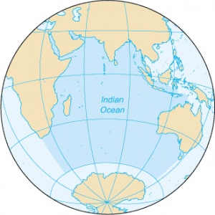

indianocean.png

The Indian Ocean is one of the world's major oceans, known for its vast expanse, diverse coastal regions, and significant influence on global climate and trade. The Indian Ocean is situated in the eastern hemisphere and extends between the eastern coast of Africa, the western coast of Australia, the southern coast of Asia, and the northern coast of Antarctica. It covers approximately 70.56 million square kilometers (27.24 million square miles), making it the third-largest ocean on Earth.

Marine life in indian ocean

1. Giant Clam

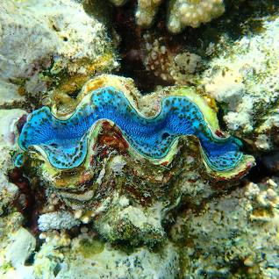

giantclam_creaturesinindianocean.png

1. Sea cows

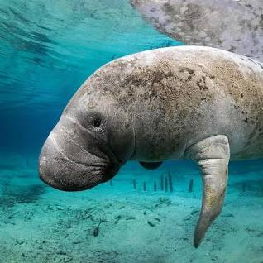

seacows_creaturesinindianocean.png

1. Reef fish

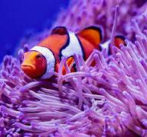

reeffish_creaturesinindianocean.png

1. Sea Turtles

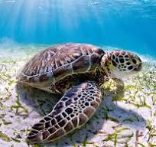

seaturtles_creaturesinindianocean.png